The Second Vatican Council tells us:
Since parents have given children their life, they are bound by the most serious obligation to educate their offspring and therefore must be recognized as the primary and principal educators.…Parents are the ones who must create a family atmosphere animated by love and respect for God and man, in which the well-rounded personal and social education of children is fostered. Hence the family is the first school of the social virtues that every society needs. It is particularly in the Christian family, enriched by the grace and office of the sacrament of matrimony, that children should be taught from their early years to have a knowledge of God according to the faith received in Baptism, to worship Him, and to love their neighbor. Here, too, they find their first experience of a wholesome human society and of the Church. Finally, it is through the family that they are gradually led to a companionship with their fellowmen and with the people of God. Let parents, then, recognize the inestimable importance a truly Christian family has for the life and progress of God's own people.
(Paul VI, Gravissimum educationis [Declaration on Christian Education], Vatican Website, October 28, 1965, sec. 3, accessed June 20, 2017, http://www.vatican.va/archive/hist_councils/ii_vatican_council/documents/vat-ii_decl_19651028_gravissimum-educationis_en.html.)

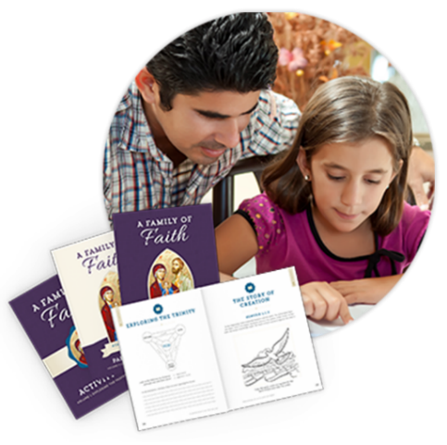
In order to better fulfill the call of Vatican II, we are moving to an outstanding new home-based method of catechetical instruction. Some key advantages to this type of program:
- Children won't simply learn the faith; they'll live it in the home as parents learn how to develop a vibrant Catholic family life.
- It is more flexible than PSR for parents and catechists alike.
- Children witness their parents engaging with the Faith as they collaborate on lessons.
- Your parish catechists gather parents once per month to catechize them through insightful teachings and discussions. This meeting is meant to help parents assume their role as the primary educator and catechist of their children. PSR children are to come as well but they will go to a different room for review and activities.
- Over the course of the month, parents teach two lessons to their children at home with the easy-to-use A Family of Faith parent guide and student activity books.

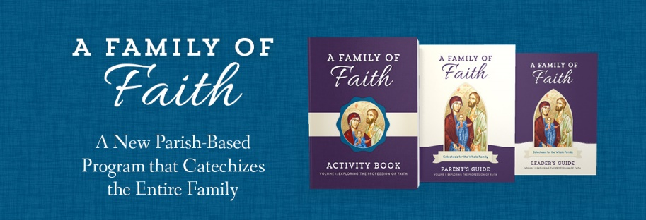
Two integral components of the new format are the Parent’s Guide and the Children’s Activity Book. An overview of each:

The Parent's Guide
This book provides parents with a ready-to-use guide for engaging their children with the Faith, including age-appropriate talking points and readings, instructions for activities and craft projects, stories of saints, and suggestions for living the Faith at home.
- Background essays covering each month's content
- Notes for conveying this content to children in age-appropriate ways (the same resources are used regardless of grade level)
- Instructions for activities and craft projects
- Stories of the saints and other notable Catholics
- Suggestions for living the faith at home, such as…
  - Guidance for creating and decorating a prayer space
  - Prayers for special occasions
  - Tips for talking about tough subjects
  - Ways to bring the liturgical year to life in the home

The Children's Activity Book
This resource will help children come to know the Catholic Faith through fun games and crafts, age-appropriate readings, journal pages, coloring pages, saints’ stories, and other activities — all of which are to be completed with the parent. Each child will have his or her own book.
- Activities in the Children's Activity Book include…
  - Age-appropriate readings and activities
  - Scripture memorization and copy work
  - Prayer memorization
  - Saints biographies
  - Games and crafts
  - Drawings and coloring pages
  - Journal pages
  - Prompts for original prayers and reflections

I invite you to learn even more about the program by going to https://sophiainstituteforteachers.org/shop/family-of-faith. You are also welcome to contact our DRE at rgrebenc@saintjohnofthecross.org or at 216.289.0770 x18.

